Dating Simulator
  - Using Reinforcement Learning to Simulate Dating Behavior on Dating Apps

Daniel Veretenov
Khoury College
Northeastern University
Boston, MA USA
veretenov.d@northeastern.edu
Daniel Xu
Khoury College
Northeastern University
Boston, MA USA
xu.dani@northeastern.edu

ABSTRACT
In the age of digital connectivity, dating apps have become a key avenue for young adults seeking meaningful relationships, offering avenues to meet, connect, and explore compatibility. However, for many users, obtaining desirable matches often feels opaque and unpredictable, with experiences ranging from quick success to prolonged frustration. This project addresses these challenges by designing a model that seeks to optimize strategies for maximizing both the quality and quantity of matches on dating applications. Leveraging reinforcement learning (RL), the model mimics dating outcomes based on user interactions, aiming to enhance match success rates and user satisfaction.
1 Introduction
1.1 Project Objectives
The primary objective of this project is to develop a model that learns optimal strategies for increasing successful matches on dating apps, emphasizing not only the number of matches but also the quality and compatibility of these matches. This objective has both a functional and a user-focused dimension: functionally, the project seeks to explore how reinforcement learning (RL) can be applied to simulate and improve user matching strategies in realistic dating scenarios; from the user perspective, it aims to create an actionable framework that users can adopt to boost both their match rates and satisfaction on dating platforms.
The model will employ reinforcement learning to dynamically adjust swipe behavior, considering various user-specific attributes such as attractiveness, preferences, and demographic details. Through this approach, we aim to generate insights into what constitutes an effective matching strategy, quantifying these insights by assessing average match quality and compatibility scores. Specifically, we will evaluate the optimal balance between quantity and quality of matches by testing different levels of selectivity, where each choice impacts the likelihood of finding long-term compatible matches. By tailoring this model to explore these different pathways, our goal is to offer users evidence-backed guidance on how they can maximize both the number and quality of their matches.
1.2 Motivation
The motivation for this project is rooted in the modern dating landscape, where dating app users often encounter a complex and sometimes frustrating matching process, and where match quantity does not always equate to match quality. While a wide variety of research and dating app algorithms prioritize increasing the number of matches, users frequently report that such algorithms do not always yield meaningful or compatible connections. Understanding the mechanics of online dating platforms has become increasingly crucial as these systems play a larger role in modern relationship formation. By creating accurate simulations, we can provide insights into user behavior patterns and explain sources of frustration in current systems. This research has implications beyond dating apps, offering insights into how digital platforms mediate human relationships and potentially exemplify innate social biases.
2 Background
2.1 Importance
The importance of this work lies in its ability to shed light on the structural mechanics and biases inherent in modern dating apps. By simulating the behaviors and outcomes within these platforms, this project provides insight into the sources of frustration and inequity often experienced by users. Dating apps are not neutral tools; they are designed environments shaped by algorithms, societal norms, and commercial objectives. Understanding these underlying dynamics is critical for fostering informed discussions about the future of online relationships and technology's role in shaping human connection.
This work challenges the abstraction of relationships by distilling them into quantifiable interactions. While this simplification might seem reductive, it serves to highlight that much of what happens on dating platforms is governed by rational patterns, preferences, and incentives rather than purely emotional or serendipitous factors. By engaging with this thought, researchers, app developers, and users can better understand how these systems can reflect or fail to reflect real-world behavior.
As dating apps increasingly mediate social interactions, the risks of reinforcing biases and perpetuating inequities grow. This project emphasizes the need to address these concerns, particularly as algorithms become more central to decision-making in social contexts. It underscores that the digitalization of dating is not inherently neutral; biases embedded within algorithms can amplify preexisting social disparities, such as those based on gender or attractiveness.
2.2 Previous Work
Our project draws inspiration from several sources. We were inspired by simulations of survival environments, such as those created by the YouTube channel Primer ^{[2]}, and video analyses that delve into the social biases driving the behavior on dating apps^{[3]}. By combining these two areas, we sought to represent dating apps as a game where agents would make the most rational ways to maximize their reward.
Numerous research papers have analyzed the complexities of speed dating environments, similar to the online dating experience nowadays, uncovering interesting patterns, such as the normal distribution of attractiveness [1][2] and the selectivity women demonstrate when presented with many options [3] - behaviors we’ve chosen to implement in this project. Other articles mention the negative effects, burdened mental, and difficulty attributed to online dating with statistics that help define the progression of our project. We haven’t encountered a scientific paper or research article examining how machine learning can model dating app behavior, so we hope to be pioneers in this field of research.
2.3 Challenges
Ultimately, there will be intricacies within dating that we can never simulate with 100% accuracy. While generating our data isn’t ideal nor precise, data on specific profiles and match behavior is limited by privacy concerns, so generalizations must be made. Additionally, attractiveness is of course partially subjective, so there will always be limitations to how accurately we can model human behavior in dating scenarios.
3 Methods
3.1 Preliminaries
Our study consists of a decentralized partially observable Markov decision process (DEC-POMDP) with shared rewards in a dating environment. A DEC-POMDP is defined by$〈S, A, O, R, P, N, γ$〉where S represents the joint space of all of the agent's profiles and their interactions, this includes their attractiveness traits and their match histories. The A is the shared action space for each agent i, this is their possible swipe decision which is left or right. The observation function $O$ provides each agent_{i} with a local observation $o_{i}=O(s;i)$ at global state s, which contains information about the visible potential matches and their attractiveness attribute within the observation window^{[7]}.

$P(s' | s, A)$ shows how likely the dating environment will change from the current state s to the new state s’ when all agents are done with their swipes $A = (a_1, ... , a_N)$^{[7]}. R(s|A) represents the shared reward function that provides feedback based on the successful matches and the quality of matches across the whole population. the discount factor $γ$ dictates if the agent wants to match immediately or wait for more swipes.

Each agent uses a policy $πθ(a_{i} | o_{i})$ that helps the agent decide how to swipe ($a_{i}$) based on what they see about their potential matches ($o_{i}$). While the agents act independently based on their local observations, in the end, they jointly optimize their long-term reward:
$J(θ) =E_{A_{t},s_{t}} \left[\sum_{y}{}γ^{t} R(s_{t},A_{t})\right]$

This equation adds up all of the rewards over time. Future rewards are worth less because of $γ$. The $A_{t}= ({a_{t}}^{1}, ... , {a_{t}}^{N})$ represents all agents’ swipe decisions at each moment t. This structure encourages the agents to not just look at themselves but look at the whole dating environment in their matchmaking decisions^{[7]}.
3.2 Policy Network Variants
In our multi-agent environment, we tested 2 variants of PPO. Each variant approaches reward optimization differently while maintaining a similar system structure.
3.2.1 Regular PPO
The standard PPO implementation optimizes^{[10]}:
$L_{u}(θ_{u})= E_{t}\left[min(t_{u,t}(θ_{u}) A_{u,t},clip(r_{u,t}(θ_{u}),1-0.2,1+0.2)A_{u,t})\right]$
where: $r_{u,t}(θ_{u}) =\frac{π_{θ_{u}}(a_{u,t} | o_{u,t})}{π_{{θ_{u}}^{old}}(a_{u,t} | o_{u,t})}$represents the probability ratio. The advantage $A_{u,t}$ is computed using Generalized Advantage Estimation:
$A_{u,t} = δ_{t}+(γ λ)δ_{t+1}+...+(γ λ)^{T-t+1}δ_{T-1}$
where: $δ_{t}=r_{t}+γV(s_{t+1})-V(s_{t})$.
The value function $V(s_{t})$ is approximated by a critic network to minimize:
$L_{critic}=MSE(V(s_{t}),r_{t}+γV(s_{t+1}))$
3.2.1 Monte Carlo PPO
The Monte Carlo PPO accumulated discounted rewards for all the episodes. For each episode, we compute the normalized advantages: $A_{u,t}=\frac{G_{t}-V(s_{t})}{σ+ϵ}$ where 𝜎 is the standard deviation for advantages $ϵ=10^{-8}$. The discount returns are calculated as:
$G_{t}=r_{t}+0.96r_{t+1}+(0.96)^{2}r_{t+2}+...+(0.96)^{T-t}t_{T}$
This approach stabilizes training by considering complete episode sequences when computing policy updates, mainly this is beneficial for the sparse and delayed rewards in dating environments^{[10]}.
3.3 Reward Structure
Agents were given rewards based on the structure:
$R(agent)=R_{m} +R_{a}$
where $R_{m}$is a base match reward of 0.2 for each successful match, and $R_{a}$ is the attractiveness of the agent they match with (between 0-1). The total reward for each agent is calculated at the end of each episode:
$R(agent) = \sum_{matches}{}(0.2+attractiveness(match))$
This reward structure was a balanced approach of rewarding for matching and attractiveness. We put the match reward in so the agent would still try to get a good amount of matches. The attractiveness is a bigger reward because we wanted the agent to focus more on the attractiveness than the number of matches
3.4 Network Architechture
The neural network that is implements both actors and critics components. The actor-network processes the inputs through the 2 linear layers, then transforms from the input to a hidden dimension (256) and then the output dimension. The network uses ReLU activation and then Softmax to produce action probabilities for deciding to swipe left or right. The critic network has two variants the regular PPO in which it has 2 linear layers and the Monte Carlo PPO which has 3 linear layers, both networks use ReLU for activation. The input dimension is determined by the number of attributes the agent has and the remaining swipes, while the output produces estimated values to update the policy. Each agent has a policy network, which includes an Adam optimizer and a learning rate scheduler. This architecture balances the needs of the action selection through the actor and value estimation through the critic while also keeping a small parameter space.
3.5 Window Prioritization
The environment implements a dynamic prioritized queue system that better replicates realistic dating app environments. In dating apps, if the application knows there is someone who likes you, they will feed them into your swiping feed within 5-10 swipes, so we decided to replicate the interaction. Each agent maintains a queue of “priority agents” which inputs agents that have swiped like on the agent with their next 5-10 swipes. We also put in a buffer slot in which if an agent gets a priority swipe in 5 swipes, the next 3-7 swipes will be random agents and not a priority agent. This system creates a natural flow of agents that the agent needs to swipe on knowing that in the future they will get a match and a priority in which they will get instant reward because the agent already swiped on them. This window prioritization helps simulate the dating apps better, so this environment is closer to the real-world dating app environment.
3.6 Training Process
The training process is configured with the number of days(episodes) with the number of agents that will start to interact simultaneously. This environment is initialized by stating the number of agents for each sex and the maximum amount of “like” swipes they have per episode. The agents are generated with attractiveness being distributed by a normal distribution (μ=0.5,𝜎=0.15). For each episode, agents receive observations and perform actions until they run out of “like” swipes or agents to swipe on. The observation includes the agent's attributes and the remaining swipes normalized by the maximum swipes.

Then the 2 different PPOs are implemented. The Monte Carlo PPO collects the complete episode trajectory and computes the discounted rewards. This is performed by 10 optimization epochs per episode. The Regular PPO calculates the advantages using the current value estimated and performs 8 optimization epochs. The training process is tracked using TensorBoard metrics which include the actor/critic losses, entropy, average rewards, and attractiveness-reward correlations per agent. At the end of the training, it generates a JSON that includes all episode metrics such as total matches, total reward, average reward, average match disparity, match per swipe ratio, and more for both men and women. This structured data enables us to create detailed analysis of agent behavior and match patterns.
4 Data
4.1 Data Sources
All of the data for this project will be self-generated with an attempt to model a representative sample of dating app users in the US. More data will be generated as our RL model continues to learn and evolve - data regarding positive/negative outcomes, # of matches, quality of matches, etc., allowing us to visualize our model’s growth and the different behavioral trends that appear. Here is a representation of the data we used in our various simulations:

Simulation | # of Days | # of Men | # of Women | Men Max Swipes | Women Max Swipes
Control | 100 | 50 | 50 | 50 | 50
Gender Gap | 100 | 50 | 30 | 20 | 20
Selective | 100 | 50 | 50 | 20 | 10
Combined | 100 | 50 | 30 | 20 | 10

4.2 Suitability of Data
Our approach to data generation is well-aligned with findings from prior research on dating behaviors and preferences, particularly in the context of speed dating and online dating platforms. Studies have consistently shown that attractiveness is not only a primary factor in determining initial romantic interest for both men and women [8], but also the primary factor in speed dating “success” [3]. These studies underscore the relevance of attractiveness as a focal trait in our simulated environment whereby basing our model on attractiveness-driven interactions, we ensure that the simulation captures one of the most critical variables influencing outcomes in real-world dating scenarios.
Analyses of dating app platforms like Tinder and Hinge reveal two other stark figures. One, that there exists a significant skew in the number of men vs. women on dating apps. Figures range from all the way up to a 3:1 ratio of men to women [9]. Secondly, that women exhibit higher selectivity than men in both speed dating and online dating contexts. Studies have found that women on dating apps tend to like as few as 5% of the men they encounter, while men like upwards of 61% of the women they view [10]. This stark disparity in liking behavior is echoed in the mechanics of our simulation, where selectivity biases were implemented to replicate such real-world phenomena. Other research supports this hypothesis that increased options lead to heightened pickiness among women, whereas men’s selectivity remains relatively unaffected by an abundance of choices [3]. These insights informed our decision to simulate distinct behavioral patterns for men and women in our model, thereby enhancing its alignment with observed human tendencies.
Although we generated profile data rather than relying on real user data, this decision allows us to sidestep ethical concerns related to privacy and consent while maintaining a high degree of realism. By tailoring the number and types of profiles to reflect real-world demographics and behavioral norms, we ensured that the environment mimics real-world dating dynamics. This not only provided a realistic context for testing our reinforcement learning model but also enabled us to explore critical patterns in gendered decision-making and matching behavior.
5 Results
We were successfully able to implement a reinforcement learning environment where agents can swipe and match with each other while receiving reward and feedback for every action. We started by creating a configuration with a clear winning strategy, swiping on every person they encounter, to confirm that the agents were learning instead of making random choices. As seen in the figure below, the agents progressively learned to increase the number of right swipes they made to therefore increase the number of matches and reward they received.
Fig 1.
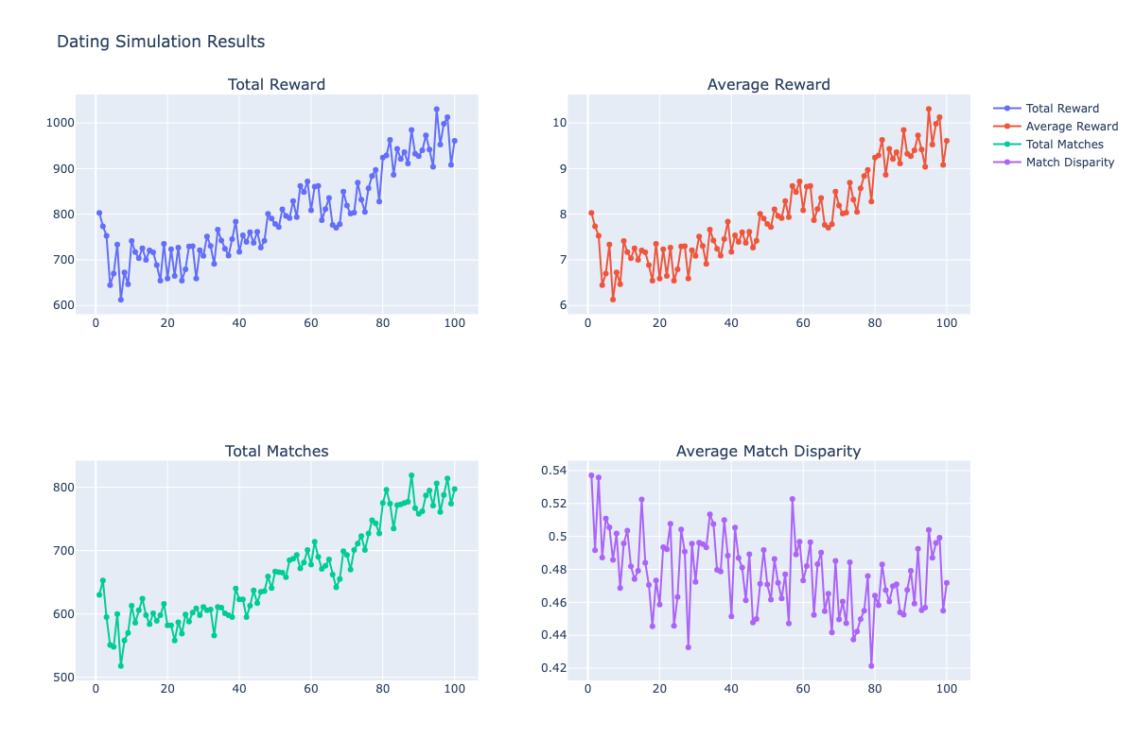
Control group where agents learned over time that each profile shown should be swiped right on to maximize reward. Over hundreds of epochs, agents progressively understood the “winning” strategy, increasing overall reward.

In this environment, we found that, unsurprisingly, the playing field was completely level between men and women. Match attractiveness, average # of matches, and match rate was equal between men and women, suggesting an equitable and symbiotic environment.
Fig 2.
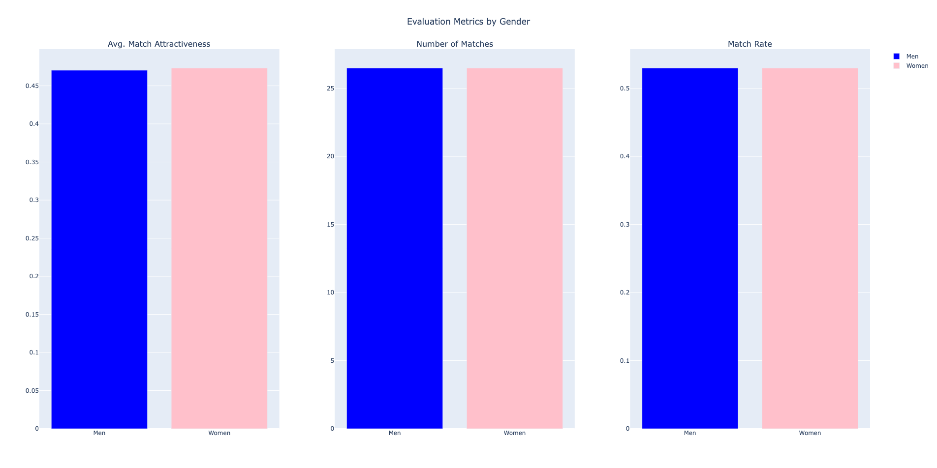
Control group demonstrating equitable environment between men and women
In our next assessment, we incorporated a gender disparity, one analogous to the gap one would find on modern day dating apps. With 50 men and only 30 women, the concept of supply and demand began to exact its force on the simulation, resulting in a greater # of matches and match rate per woman.
Fig 3.
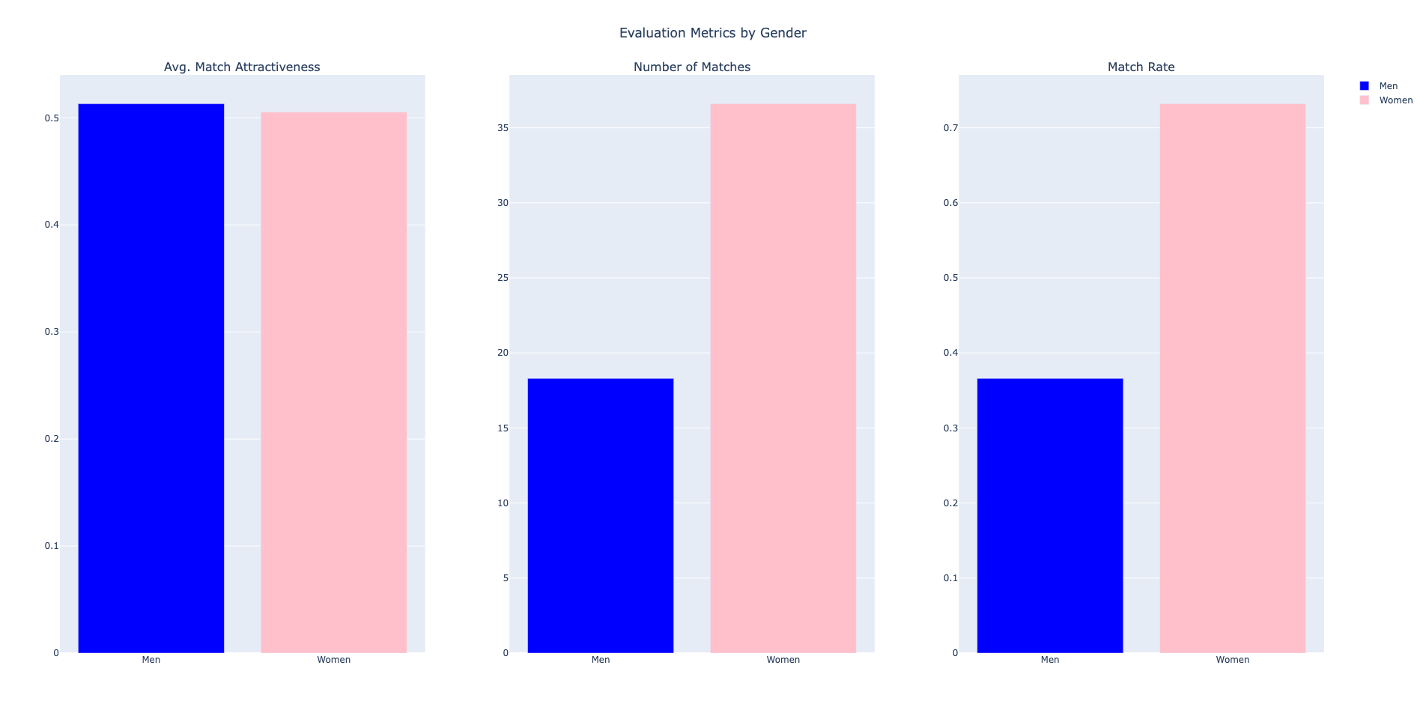
Results of gender disparity simulation where more men match over a fewer number of women, resulting in a consequential number of men being left out.

In this assessment, we see a disparity in a number of matches as expected. The number of matches for men is two times lower than women. Interestingly the match rate stayed the same. Indicating that if there is no selectivity gap, the match rate and the number of matches have similar behavior.

Fig 3.
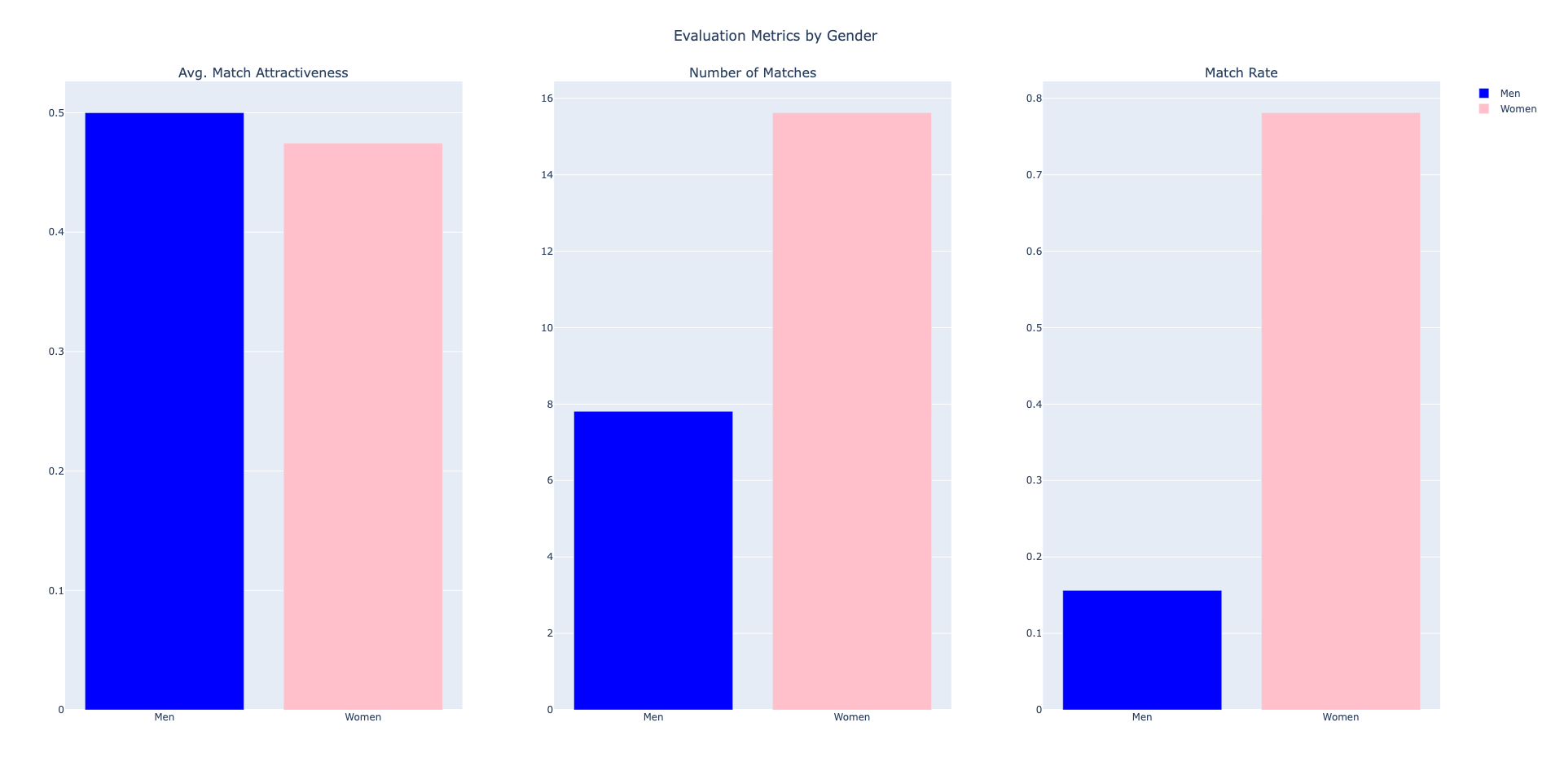
Results of gender disparity and selectivity gap simulation where more men are in the environment and women have less “like” swipes, leading to an even greater disparity in match rate between men and woman

In another assessment, we kept the gender present in our previous test, but also added a selectivity gap. In this test, we kept 50 men and 30 women, but reduced the maximum number of swipes per woman to replicate their selective tendencies online. The men had more swipes to distribute, while the women with fewer swipes, had to be more selective in the profiles they chose to swipe on.

In this assessment, we found that the playing field was further skewed with men having a significantly lower match rate. Attractiveness stayed around the same, but the number of matches halved due to fewer women and more difficulty in finding women who reciprocated interest. This was reflected in the significantly lower match rate experienced by men compared to women.
Together, the simulations illustrated the interplay of demographic and behavioral factors in dating app environments, each adding a new layer of complexity and realism. This progression allowed for a nuanced exploration of how structural inequities and individual behaviors interact, providing a lens through which to understand the social dynamics of these platforms. The findings highlight the need for thoughtful design considerations to address and mitigate the inherent biases and challenges these environments perpetuate.
6 Discussion
6.1 Limitations
While this project successfully modeled aspects of human behavior on dating apps, several limitations constrained its realism and the extent of its insights. One primary limitation was the inability of the PPO agents to associate each reward with the specific swipe decision that generated it. This disconnect prevented our agents from developing more nuanced decision-making skills, as they could not learn from individual actions in a targeted manner. Instead, they optimized for broader outcomes, which led to less precise learning and suboptimal strategies over time. Although we implemented delayed reward policies such as Monte Carlo, we still noticed a lack of sophistication in agent behavior.
Another notable constraint was the oversimplification of the simulation’s inputs and reward functions. The project considered attractiveness as the sole factor driving user behavior, omitting the myriad complexities of real-world dating dynamics. In reality, traits such as personality, shared interests, location, and even the presence of external social norms influence matching outcomes. By excluding these factors, the simulation loses some fidelity to the real-world environment it seeks to emulate.
Implementing just one trait was done, in part, to counter another significant challenge; the computational expense of reinforcement learning. Training PPO agents over even a few hundred epochs required considerable time and computational resources. This limitation restricted the scope of experimentation, such as testing alternative reward functions or larger populations. Without robust hardware or cloud computing resources, the high cost of RL limits its accessibility for future research, presenting a barrier to deeper exploration of further simulations.
Other potential limitations include the simplified implementation of gender biases and selectivity, which, while reflective of certain tendencies, may not fully capture the diversity and fluidity of real-world behaviors. Moreover, the absence of a feedback loop simulating user dissatisfaction, burnout, or churn overlooked critical dynamics that drive engagement and disengagement in online dating apps.
Despite these constraints, this project provided valuable insights into behavioral modeling and highlighted key areas for future research. Addressing these limitations could lead to a more comprehensive and actionable understanding of dating app dynamics, ultimately bridging the gap between simulation and reality.
6.2 Conclusion
Through this project, we successfully modeled and replicated human behavior on dating apps by incorporating gender-specific dynamics and selective matching biases. By simulating these real-world tendencies, such as women being more selective and men swiping more frequently, we observed outcomes that align with observed patterns in dating app behavior.
The results demonstrated that women, on average, achieved more attractive matches, higher swipe-to-match ratios, and generally had more options available compared to men. Although our model was limited in its ability to develop more complex understandings between matches and rewards, these findings nonetheless provide a compelling look at how inherent behavioral differences and selectivity biases can shape the dynamics and outcomes of digital matchmaking systems.
Importantly, these results underscore that dating apps operate on preexisting human social biases. These platforms often amplify existing inequities in dating dynamics, such as disparities in match rates and perceived value between genders. Addressing these issues in the United States will require concerted effort and a commitment to fairness in algorithmic design. However, dating app companies may not feel compelled to address these imbalances. Their ultimate goal is to drive user engagement and activity, which these biases may paradoxically support by creating dissatisfaction and incentivizing continued use of the platform.
These insights remind us that the digital systems we build are not neutral—they reflect and can perpetuate societal structures. This project not only highlights the importance of understanding social behaviors in simulations but also showcases the potential of reinforcement learning to explore and better understand complex real-world dynamics. These insights can inform the design of fairer and more effective algorithms in dating apps or other matchmaking platforms. This will help us identify the necessary modifications to dating apps that could improve long-term success for all users.
REFERENCES
[1]
T. S. Roth, I. Samara, J. O. Perea-Garcia, and M. E. Kret, “Individual attractiveness preferences differentially modulate immediate and voluntary attention,” Scientific Reports, vol. 13, no. 1, Feb. 2023, doi: https://doi.org/10.1038/s41598-023-29240-5.
[2]
S. Luo and G. Zhang, “What Leads to Romantic Attraction: Similarity, Reciprocity, Security, or Beauty? Evidence From a Speed-Dating Study,” Journal of Personality, vol. 77, no. 4, pp. 933–964, Aug. 2009, doi: https://doi.org/10.1111/j.1467-6494.2009.00570.x.
[3]
G. J. Hitsch, A. Hortacsu, and D. Ariely, “What Makes You Click? Mate Preferences and Matching Outcomes in Online Dating,” SSRN Electronic Journal, 2006, doi: https://doi.org/10.2139/ssrn.895442.
[4]
J. Schulman, F. Wolski, Prafulla Dhariwal, A. Radford, and O. Klimov, “Proximal policy optimization algorithms,” 2017. https://arxiv.org/abs/1707.06347
[5]
Alexey Skrynnik, A. Andreychuk, K. Yakovlev, and A. Panov, “Decentralized monte carlo tree search for partially observable multi-agent pathfinding,” 2023. https://arxiv.org/abs/2312.15908
[6]
C. Liu and G. Liu, “JointPPO: Diving deeper into the effectiveness of PPO in multi-agent reinforcement learning,” 2024. https://arxiv.org/abs/2404.11831
[7]
C. Yu et al., “The surprising effectiveness of PPO in cooperative multi-agent games,” 2022. Available: https://openreview.net/forum?id=YVXaxB6L2Pl
[8]
R. Fisman, S. S. Iyengar, E. Kamenica, and I. Simonson, “Gender Differences in Mate Selection: Evidence From a Speed Dating Experiment,” The Quarterly Journal of Economics, vol. 121, no. 2, pp. 673–697, May 2006, doi: https://doi.org/10.1162/qjec.2006.121.2.673.
[9]
B. Bailey, “Tinder Statistics 2023: All You Need to Know about the Dating app!,” ROAST, 2023. https://roast.dating/blog/tinder-statistics
[10]
B. Neyt, S. Vandenbulcke, and S. Baert, “Are men intimidated by highly educated women? Undercover on Tinder,” Economics of Education Review, vol. 73, p. 101914, Dec. 2019, doi: https://doi.org/10.1016/j.econedurev.2019.101914.

GITHUB REPO:
https://github.khoury.northeastern.edu/dveretenov/RizzAI

